2025 Ducky Derby QR Code Creation for Youth Sites:
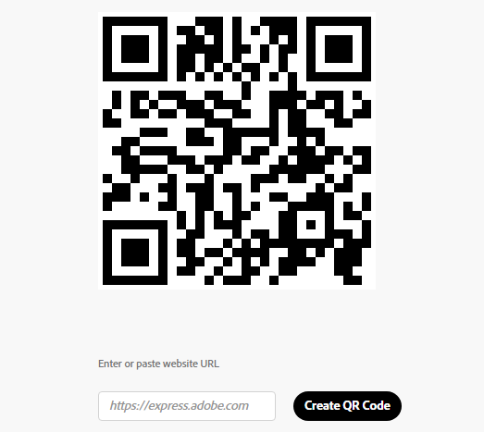
- Create your individual youth profile here.
- Copy the website for your youth profile.
- Open a separate online window and go to:
  - https://express.adobe.com/tools/qr-code-generator
  - Paste your website URL into the open box on this page (see right).
- Click “Create QR Code”
- Personalize it! Select Style, color, and File Type.
  - File Type recommended is JPEG
- The QR Code to your individual duck selling website is now generated. You can now download it and use this to create flyers or text it to direct buyers of ducks to your individual duck selling page.

2025 Ducky Derby QR Code for AVSC General Sales:
You can use the below QR Code to take people to the AVSC Ducy Derby page.
